|  |  |
| --- | --- |
| User manual Document | |
| Project Identification | |
| Project Name | CPI Project Number | |
| Container Management User Manual |  | |
| Customer Name | Customer Number | |
| Olam Mantra |  | |
| Exalca Project Manager | Customer Project Manager | |
|  |  | |

|  |  |  |  |
| --- | --- | --- | --- |
| Document Identification | | | |
| Author | | Document Location (repository/path/name) | | |
| Vivek Satavase | |  | | |
| Version | Status | Date (YYYY-MM-DD) | Document Classification | |
| 0.1 | Final | 07/05/2018 | Confidential - Critical | |

|  |  |  |
| --- | --- | --- |
| Revision history | | |
| Version | Date | Description | |
| 0.1 |  |  | |
| 0.2 |  |  | |
|  |  |  | |

Table of Contents

Table of Contents 2

1. Introduction 3
2. Dashboard 3
3. Stack Update 5
4. Reports 6
5. Masters 6

# 

# **Introduction**

This documentation provides an instruction on how the container management is processed Also, it gives a step by step operation guide, which the users can follow to finish the process of this scenario.

# **. Dashboard**

In logging with credentials such as username and password takes to Dashboard Page.

Link : <http://10.80.0.20:8868/>

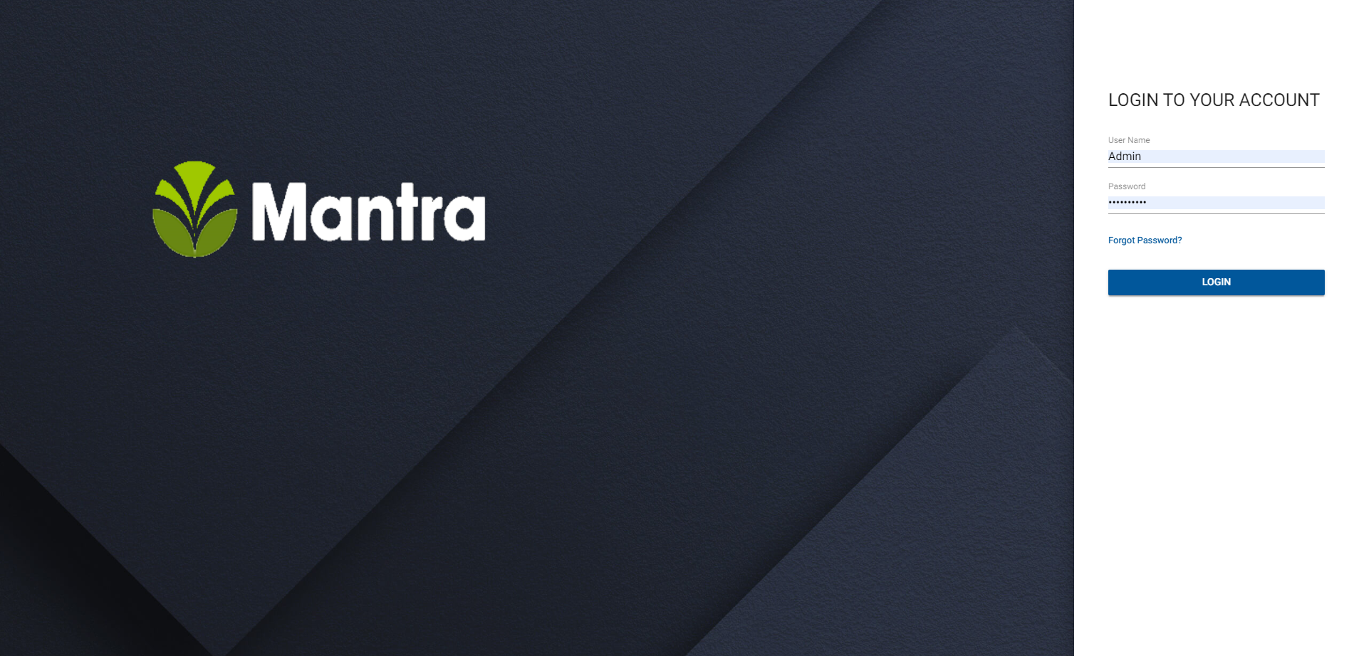

Dashboard page displays list available spaces, total containers, Completed containers and Exceptions which is shown as

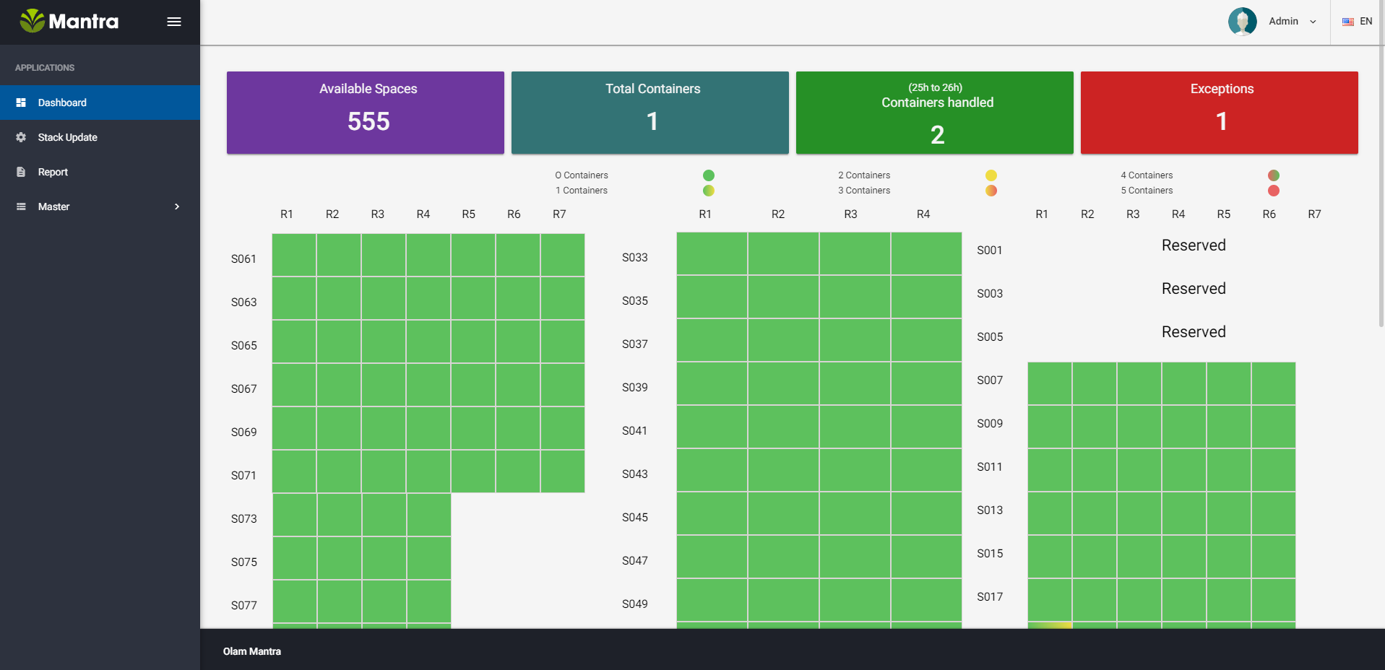

On click of each tile in the dashboard takes to tabular data of respective tile.

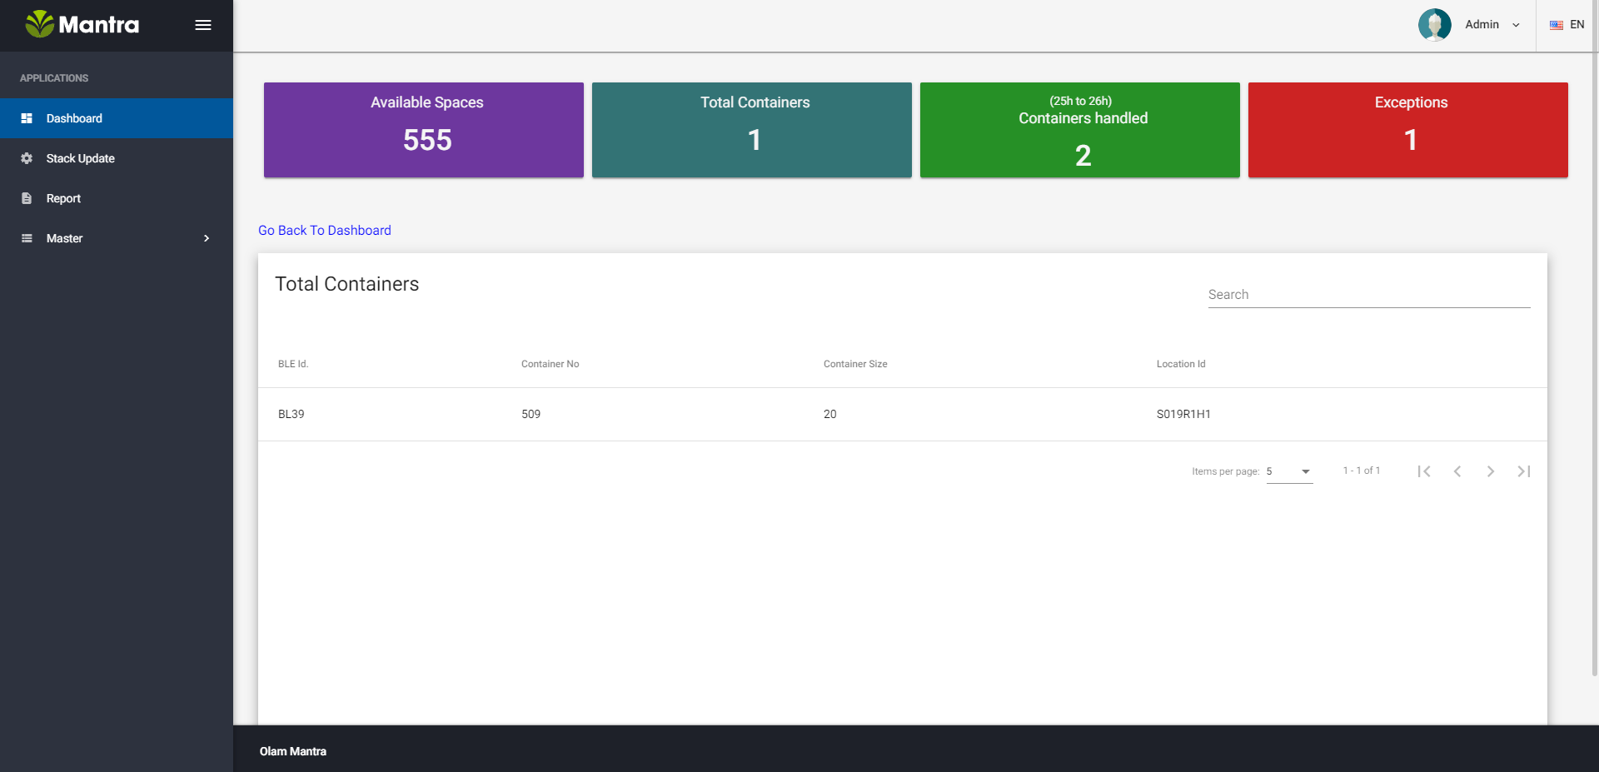

It also indicates stack wise container lists with rows

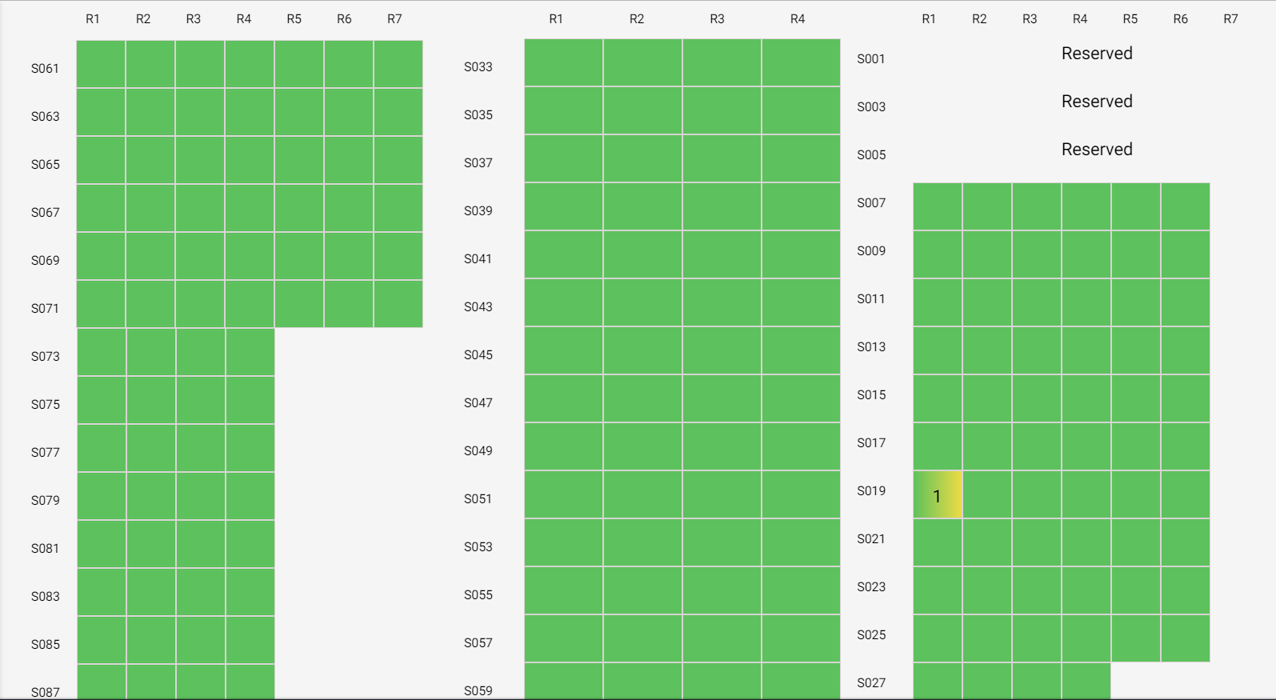

On click each stack with corresponding row leads to lists of containers in that stack.

For Example :-

Stack number S019 contains a container which is shown in the below figure.

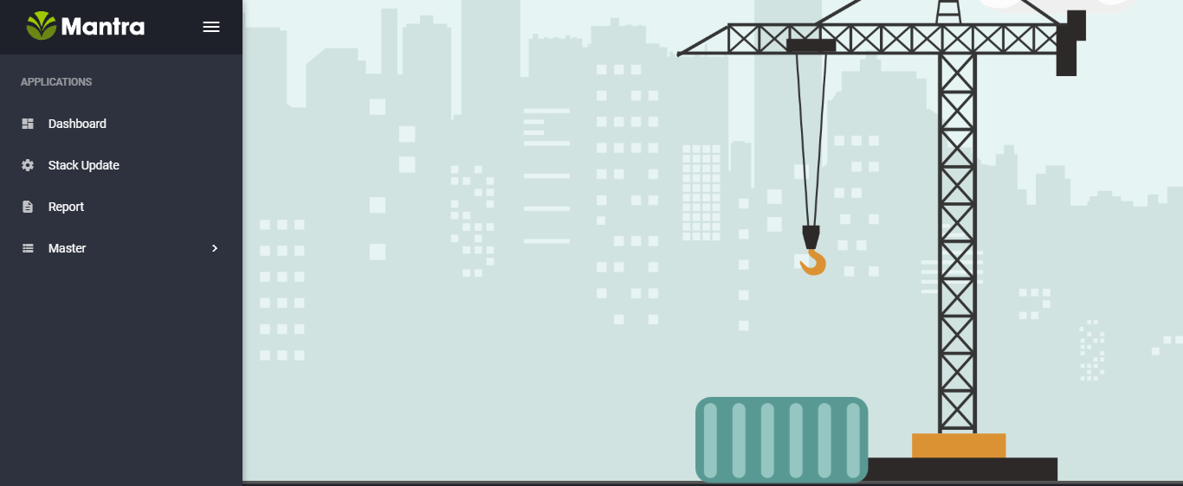

On Click of each container displays the in detail of Container which includes Container No ,size and type

and all other details.

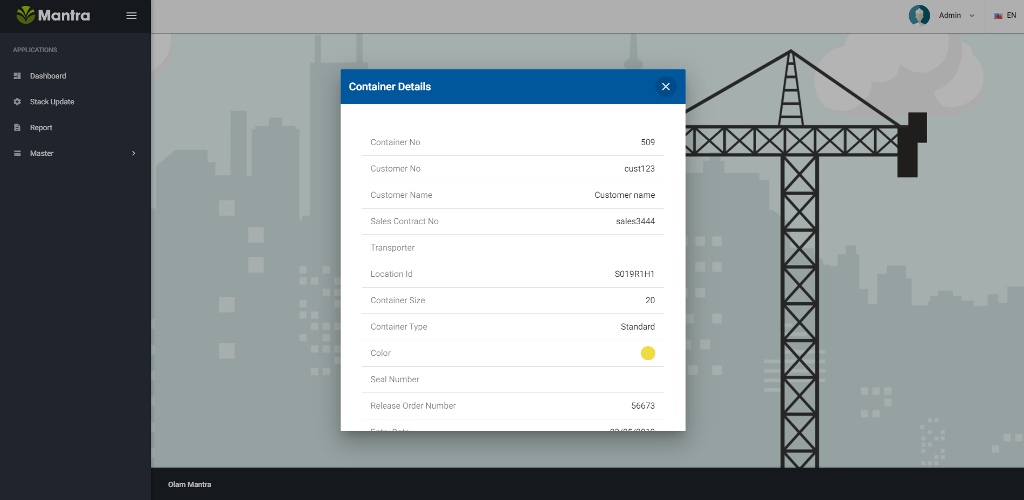

# **. Stack Update**

In this menu the stack is listed and on selecting stack the respective gateway id is shown. Here user can update the stack with gateway ids

Which is shown in the below figure.

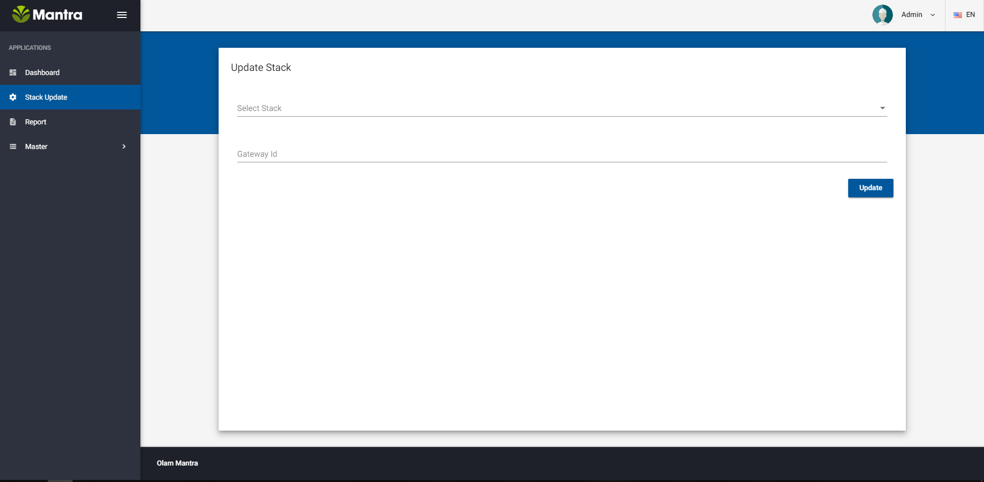

# **. Report**

This menu list out all container details based on container type (standard) , container size (20' and 40') type (full or empty) and container condition as well.

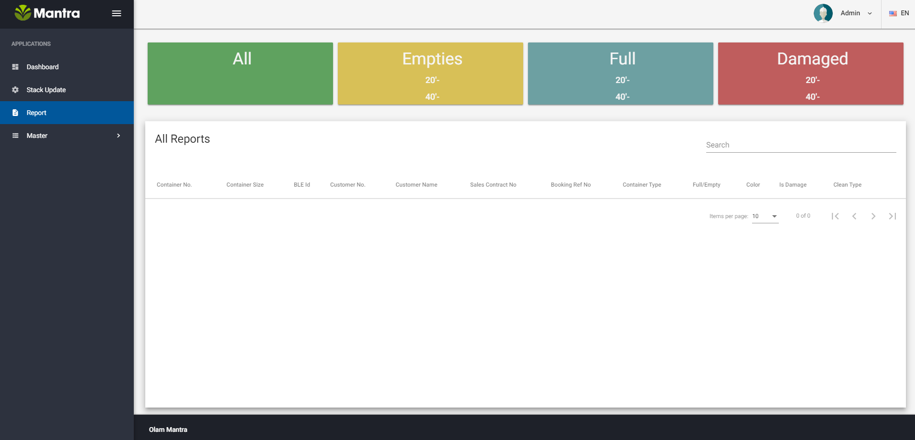

# **. Masters**

Master is the last menu of the application, Which is gives the information about users, customers an admins. Here user can be created with roles, updated and deleted as well. Open Release Order Creation Application

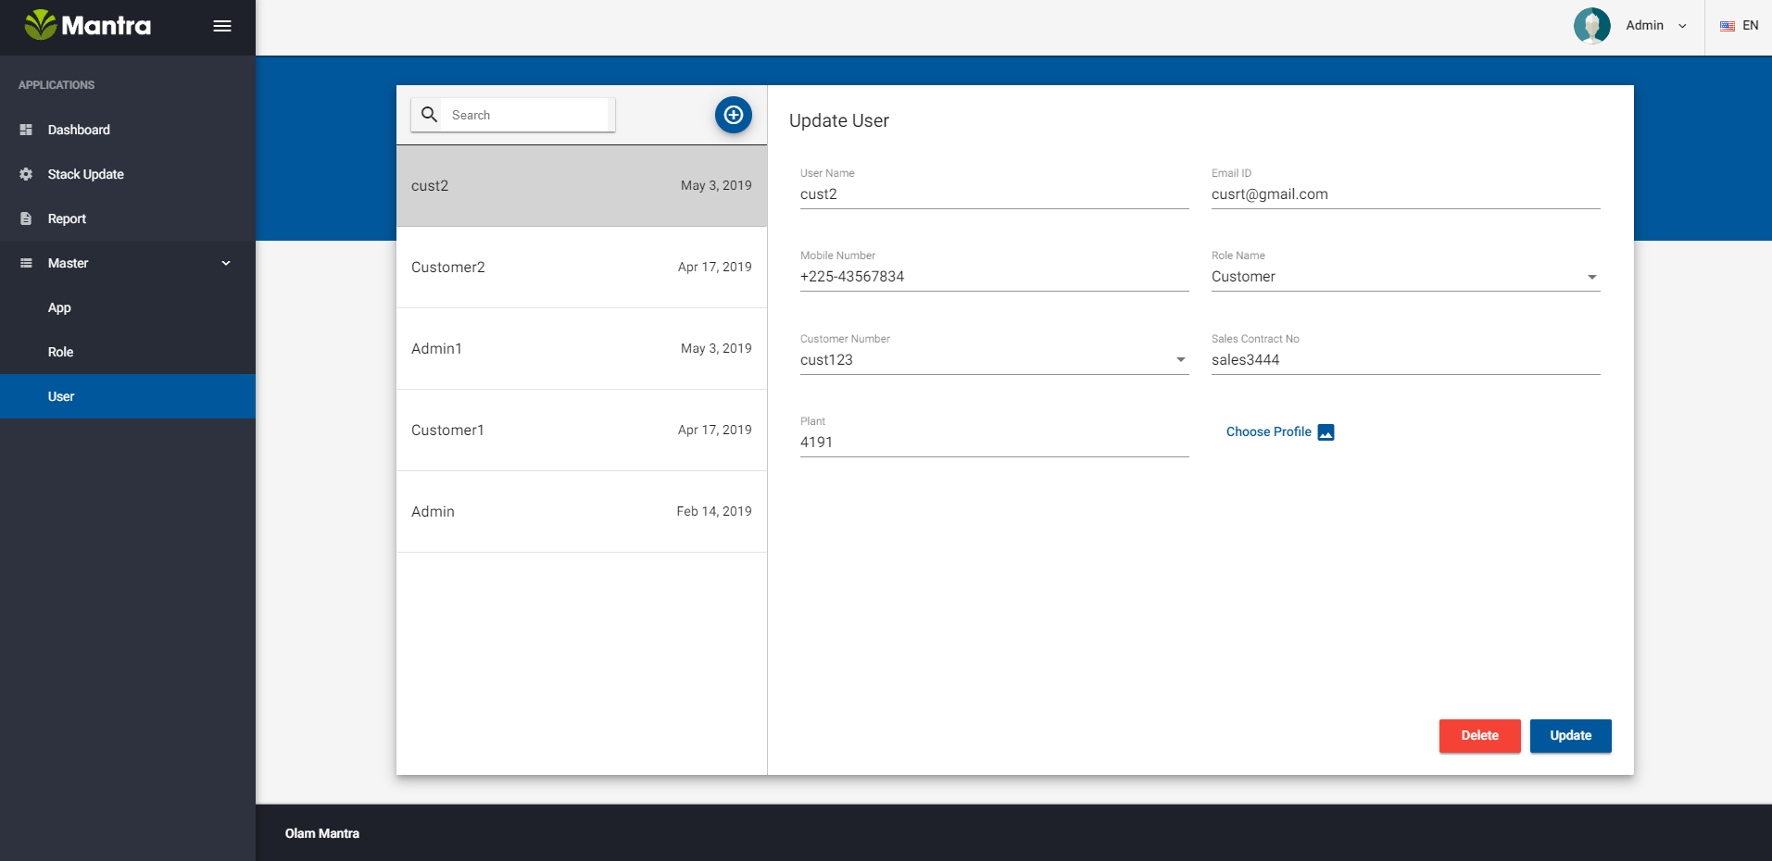

It contains sub-menu which role can be used to maintain the roles.

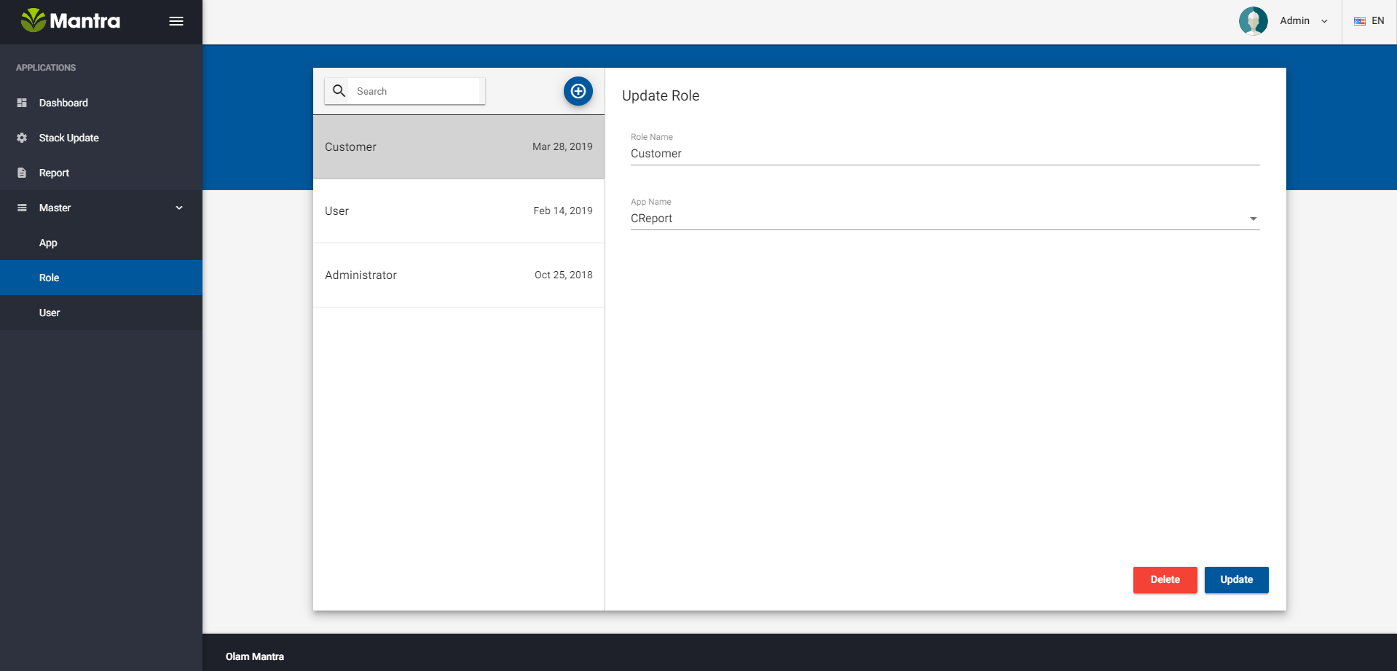

**To Add User:-**

Goto Master menu in that select sub-menu User.

To add the new user click on the + button.

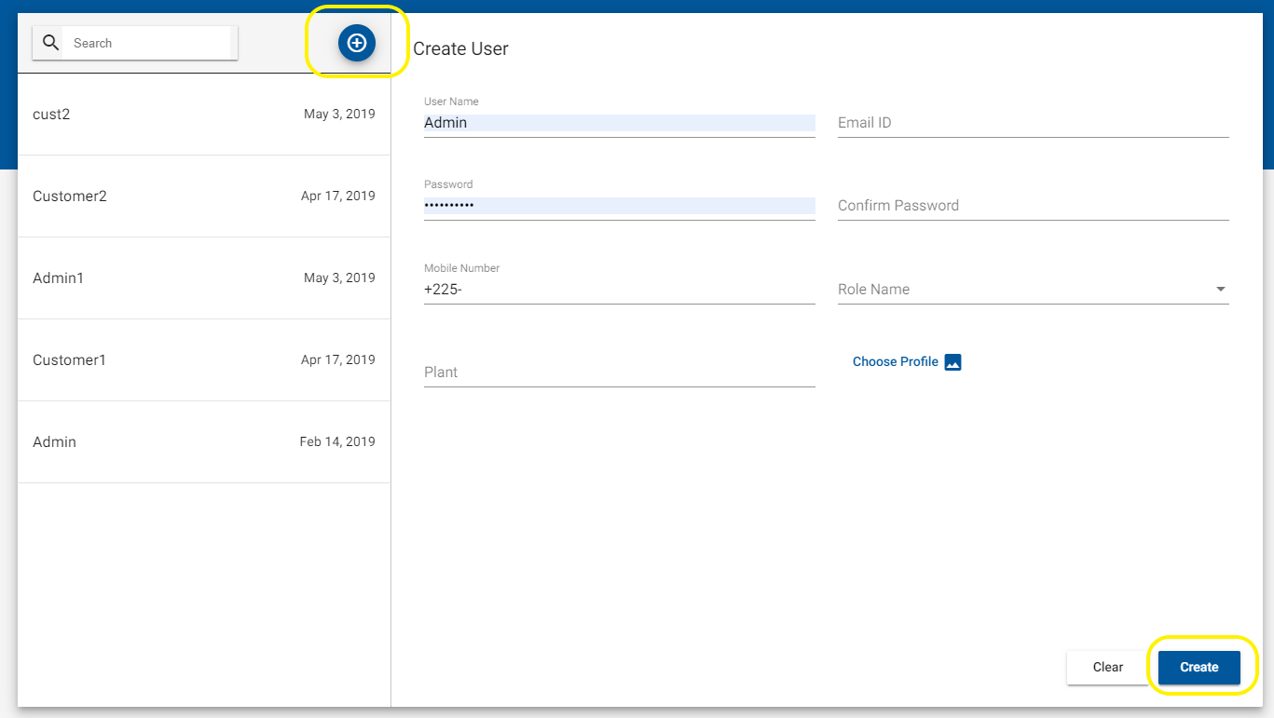

then fill the details and click on create button to add new user.

**To add Role:-**

Goto Master menu in that select sub-menu Role .

To add the new role click on the + button

add new role name and select the menus which are visible for the respective role in the dropdown as shown in the figure.

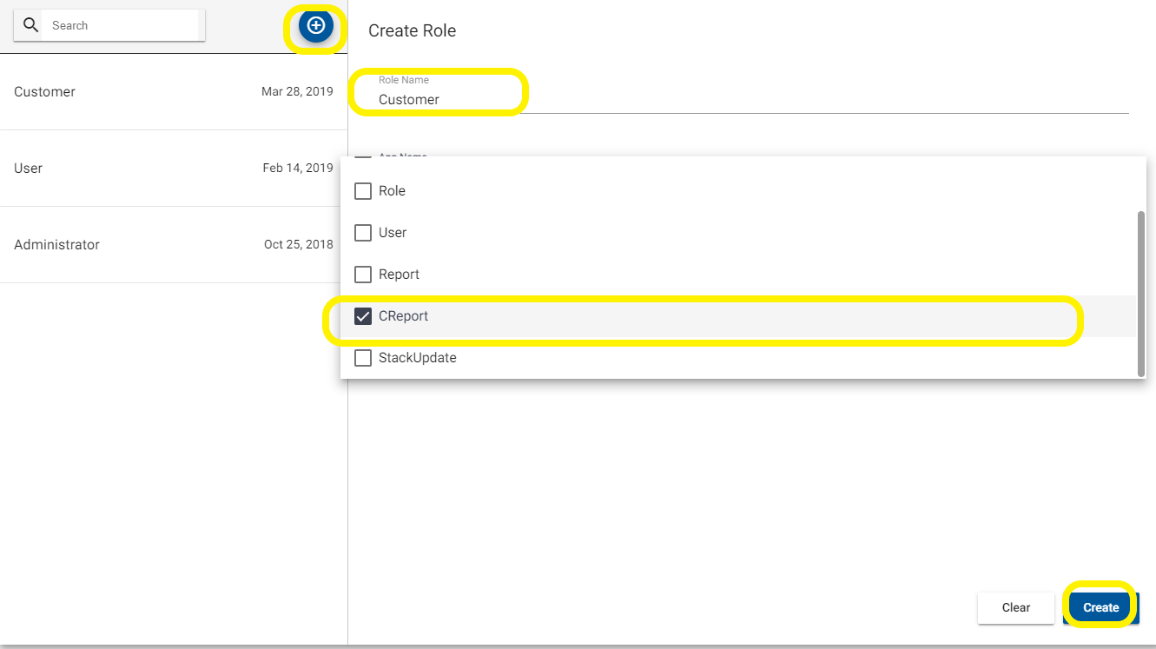

by clicking on the update buttons the roles can be updated as well.